the workers act again

Many workers destroy the machines of the textile industry

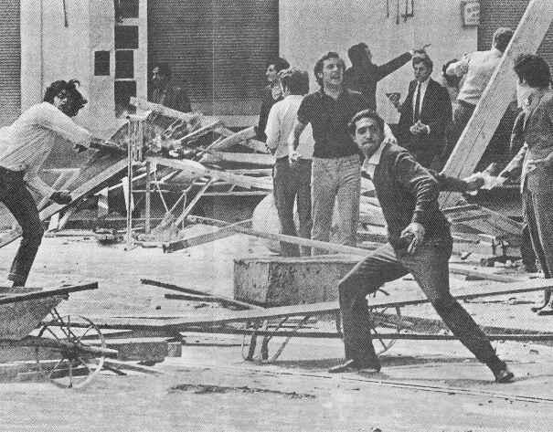
Many workers as method of protest, have demonstrated of aggressive form enter the factories and destroy the machinery.
They think that the machinery is guilty of the deterioration of his working conditions and the increasement of the unemployment.
Thanks at the increase of unemployment the workers are very angry because of it they demonstrated in order to finish with the industry.
The machinery stay with big hurts that will cost a lot of money to the owners of the factories, the owners have demanded to the group with the hope that they pay the sufficient money to reconstruct the machinery.

